# Project Design Phase-I Solution Architecture

|  |  |
| --- | --- |
| Date | 29 October 2022 |
| Team Leader | S.Mownika |
| Project Name | Project - Gas Leakage Monitoring and Alerting System |
| Maximum Marks | 4 Marks |

**Solution Architecture:**

Gas Leakage Monitoring & Alerting System for Industries has all the features as explained below

* This project helps the industries in monitoring the emission of harmful gases.
* In several areas, the gas sensors will be integrated to monitor the gas leakage.
* If in any area gas leakage is detected the admins will be notified along with the location.
* The admins can view the sensor parameters that is sent to them through the Wi-Fi module.
* The system also provides indication through an LCD display, buzzer and turns on the exhaust fan on detecting gas leakage.

# Solution Architecture Diagram:

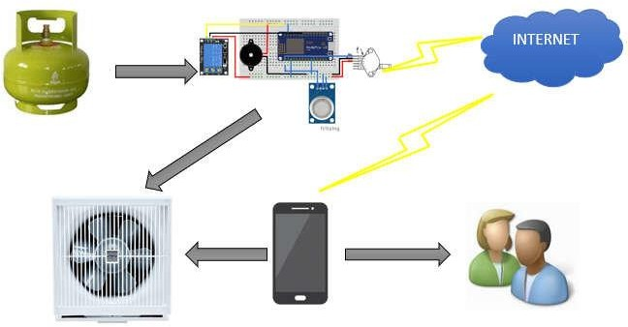

*Figure 1: Architecture and data flow of the gas leakage monitoring and alerting system.*